THE CHINESE UNIVERSITY OF HONG KONG, SHENZHEN

PHY 1002

PHYSICS LABORATORY

**Lab Report for Driven Damped Harmonic Oscillations**

*Author: Student Number:*

Haopeng Chen 120090645

September 26, 2021

Contents

**1.** **Introduction:** 3

**2.** **Theory**: 3

**3.** **Experiment Procedure:** 6

3.1 Setup 6

3.2 Resonant Frequency, Spring Constant & Disk Resonance Inertia 8

3.2.1 Resonant Frequency 8

3.2.2 Spring Constant 8

3.2.3 Disk Resonance Inertia 8

3.3 Resonance Scan 8

3.4 Damped Oscillation 8

**4.** **Raw Data:** 10

**5.** **Data & Error Analysis:** 12

5.1 Error Analysis 12

5.2 Estimated Resonant Frequency 13

5.3 Theoretical Period and Resonant Frequency 13

5.4 Resonance Curves 14

5.5 Finding Damping Coefficient Manually 15

5.6 Difference between Actual and Theoretical 15

5.7 Asymmetric of the Resonance Curves 15

5.8 Fitting Theory to Resonance Scan 16

5.9 Phase Analysis 16

**6.** **Conclusion:** 18

1. **Introduction:**

This is an experiment to study Driven Damped Harmonic Oscillations. Harmonic Oscillations are common in our daily lives. And due to the inevitable friction, we face Damped Harmonic Oscillations more frequently than Simple Harmonic Oscillations. Furthermore, in the real world, we have also to consider the external force that acted on the Damped Harmonic Oscillations. It develops the Driven Damped Harmonic Oscillations. We are experimenting to determine the various effects of friction and external force on the Harmonic Oscillations.

1. **Theory**:

The oscillating system in this experiment consists of a disk connected to two springs. A string connecting the two springs is wrapped around the disk so that the disk can oscillate back and forth. This is like a torsion pendulum. The period of a torsion pendulum without damping (*T*) is given by

where *I* is the rotational inertia of the disk and is the effective torsional spring constant of the springs. For a disk, oscillating about the perpendicular axis through its center, the rotational inertia is given by

where *m* is the mass and *r* is the radius of the disk by measuring.

The torsional spring constant is determined by applying a known torque to the disk and measuring the resulting angle (*θ*) the disk turns. Then the spring constant is given by

where is the magnitude of the known torque and is given by

where ***r*** is the position vector, ***F*** is the force vector, and *α* is the angle between the force vector and the lever arm vector.

Then, let us take a further step into Damped Harmonic Oscillations. If a damped oscillator is displaced from equilibrium and allowed to oscillate and damp out, the equation of motion is

where *b* is damping constant that depends on the characteristics of the disk and the magnet, we reorder and solute this equation to get as a function of time ():

The solution is a damped sine wave and , the angular frequency, is given by

Furthermore, let us take torque into account. When the damped oscillator is driven with a sinusoidal torque, the differential equation describing its motion is

where is the amplitude of the sinusoidal torque. And the solution is

where the amplitude of the oscillation is

And

is the phase difference between the driving torque and the resultant motion. The resonant frequency, , is given by

When the driving frequency is equal to the resonant frequency, the amplitude is a maximum. Setting in Equation (10),

1. **Experiment Procedure:**
   1. **Setup**

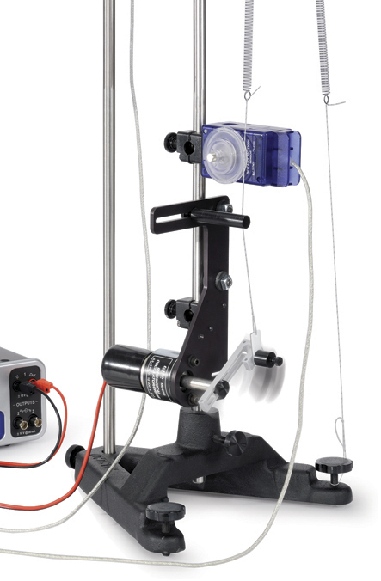Mount the driver on a rod base, as shown in Figure 1. Set the driver arm amplitude at about half of max length. Slide the first Rotary Motion Sensor onto the same rod as the driver. Also, see Figure 2 for the orientation of the Rotary Motion Sensor.

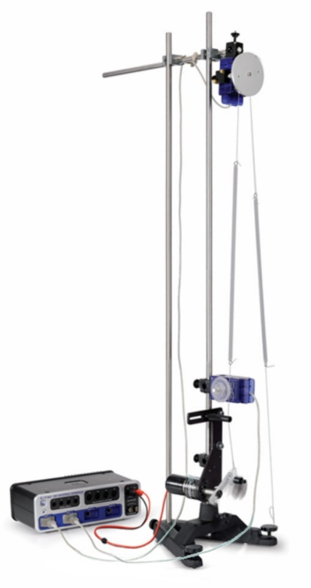On the driver, rotate the driver arm until it is vertically downward. Attach a string to the driver's arm and thread the string through the string guide at the top end of the driver. Wrap the string entirely in 2 rounds on the Rotary Motion Sensor large pulley. Tie one end of one of the springs to the end of this string. Tie the end of the spring close to the Rotary Motion Sensor.

*Figure1. Driver Setup*

Erect the second rod and connect them with a cross rod at the top for more excellent stability. And mount the second Rotary Motion Sensor on the cross rod. See Figure 2.

Tie a 40 cm length of string to the leveling screw on the base. Tie one end of the second spring to this string.

*Figure2. Complete Setup*

Cut a string to a length of about 125 cm. Wrap the string around the large pulley of the 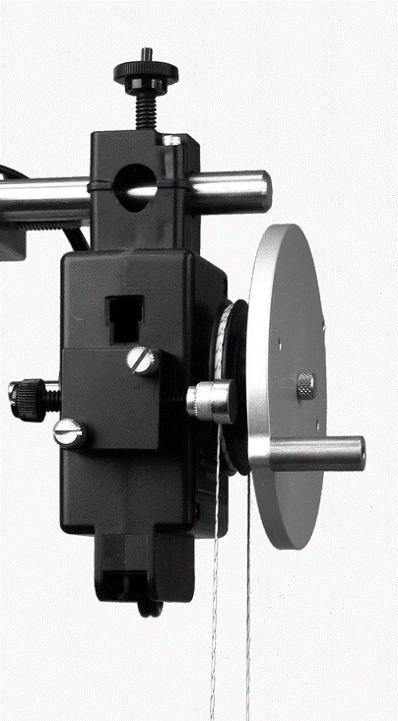second Rotary Motion Sensor three times to ensure that it would not slip. See Figure 3. Attach the disk to the Rotary Motion Sensor with the screw.

To complete the setup of the springs, thread each end of the string from the pulley through the ends of the springs and tie them off with about equal tension is each side: The disk should be able to rotate 180 degrees to either side without the springs hitting the Rotary Motion Sensor pulley.

*Figure3. String and Magnet*

Connect the sensors with the data collector and computer. Set the sample rate for both rotary motion sensors to 50 Hz. Also, set the current, voltage, stop condition, and so on in a proper way.

Test the direction of the rotary motion sensors to make sure they read positive in the same direction as shown in Figure 4. 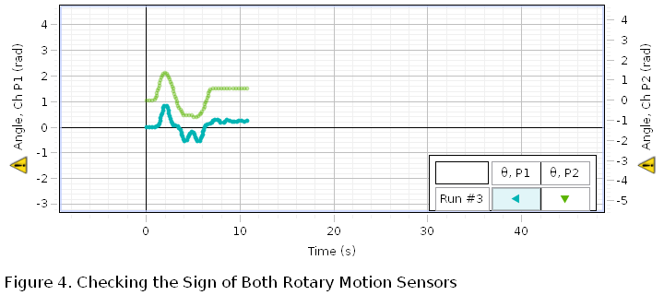

*Figure4. Checking the Sign of Both Rotary Motion Sensors*

* 1. **Resonant Frequency, Spring Constant & Disk Resonance Inertia**
     1. **Resonant Frequency**

Rotate the disk to some position and release. Then we could get a graph of the angular speed of the disk versus time on the computer. Then stop recording. Measure the period using the coordinates tool on the computer graph (Figure 5).

* + 1. **Spring Constant**

Attach a 20g weight golden cylinder to the top of one of the springs and hold it. Click the record button first. After it is recorded for a while, release the golden cylinder, and the disk starts oscillating. Until the oscillation stops, click the stop button. Remove the cylinder. Measure the radius of the groove of the large pulley and calculate the torque caused by the weight of the cylinder. Calculate the torsional spring constant.

* + 1. **Disk Resonance Inertia**

Remove the disk from the second Rotary Motion Sensor, measure the mass, the radius of the disk, and calculate its rotational inertia.

* 1. **Resonance Scan**

Put the magnet on the second Rotary Motion Sensor and keep it 6mm from the disk. Adjust the signal generator to 'Auto.' Click record and wait patiently. The driver will rotate at high speed at first and become slower and slower. When the driving voltage drops below 3.1V, the frequency is low enough to stop automatically. Then we repeated the process with a distance of 4mm and 3mm between the magnet and the disk, respectively.

* 1. **Damped Oscillation**

For the last experiment with 3mm damping distance, instead of using the Mechanical Driver, rotated the disk about 360 degrees manually and held it. Start recording first and then let go of the disk. When the disk stops, click the stop button. Apply a damped sine curve to fit the graph and record the coefficients. Compare to the theory and calculate the damping coefficient (b).

1. **Raw Data:**

The data in the following table is measured manually.

|  |  |
| --- | --- |
| Radius of the Disk () |  |
| Mass of the Disk () |  |
| Radius of the Groove of the Large Pulley () |  |

*Table1. Length and Weight of Disk and Pulley*

All data below is measured by the sensor with the computer software PASCO Capstone.

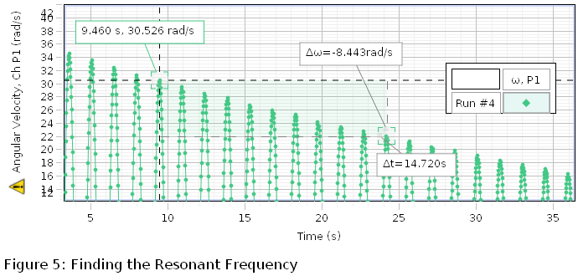

*Figure5. Finding the Resonance Frequency*

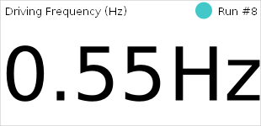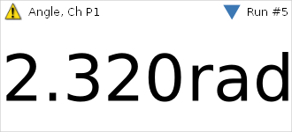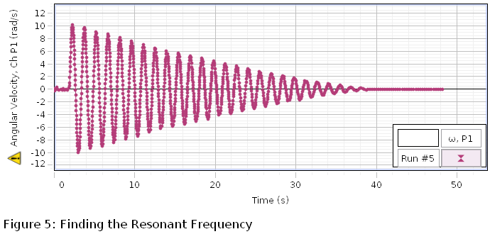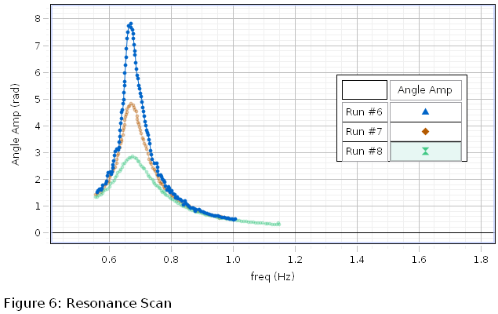

*Figure6. Finding Spring Constant*

*Figure7. Resonance Scan (6mm: Blue, 4mm: Orange, 3mm: Green)*

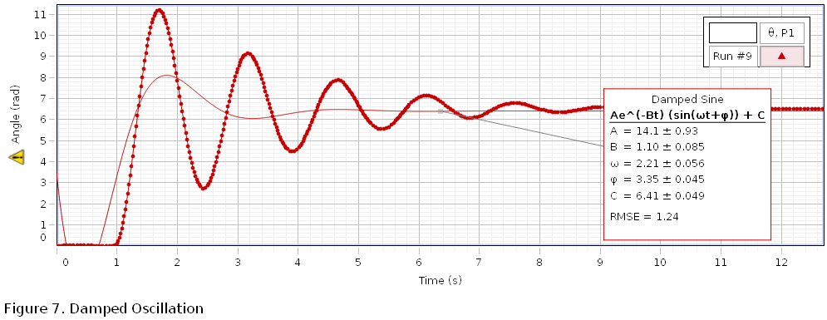

*Figure8. Damped Oscillation*

1. **Data & Error Analysis:**
   1. **Error Analysis**

The length is measured manually. So, the resolution of the radius of the disk and the groove of the large pulley is and deviation is considered as . Also, the weight of the disk is measured by an electric scale. Therefore, the resolution is , and the deviation is . According to the manual of PASCO Capstone, the revolution deviation of rotary motion sensor is (angular), equivalent to (radian). And, for time measurement, it is

To deal with the propagated errors, the following theorem is used.

**Theorem:** If function is determined by independent random variables, namely , and ; that is , the standard error for is given by

where are estimated errors. In addition, the result is rounded off to the same number of decimal places as the least number of decimal places in any number involved when adding up values with different numbers of significant places.

* 1. **Estimated Resonant Frequency**

According to Figure 5, we take ten periods to calculate their average considering our estimated period to decrease random error.

* 1. **Theoretical Period and Resonant Frequency**

To get the theoretical period and resonant frequency, we must calculate disk rotational inertia and torsional spring constant. According to Table 1, Equation 2, and 4,

**Remark:** As the string is expected vertical, the could be considered the gravitation of cylinder and is propositional to .

Then, according to Equation 1, 3, and Figure 6,

Thus, we get theoretical period and resonant frequency .

* 1. **Resonance Curves**

According to Figure 7, comparing these three curves, it is clear that they raise to the maximum at the same frequency, which means that the magnitude of friction does not affect the frequency of the maximum angle amplitude. Also, as most plots are in a particular region of the x-axis, the magnitude of friction does not affect the width and the location of curves. But it makes a difference in maximum amplitude. Undoubtedly, the blue curve, representing the minimum friction, achieves the largest maximum amplitude. We can also point out that the magnitude of the friction is inversely proportional to the maximum amplitude.

* 1. **Finding Damping Coefficient Manually**

As shown in Figure 8, the damping coefficient

* 1. **Difference between Actual and Theoretical**

According to Figure 7, we adopt , while . Use the following equation to construct percentile difference.

There exist specific errors. However, considering the actual condition of experiment utilities, it is still acceptable.

* 1. **Asymmetric of the Resonance Curves**

If we take further consideration of Figure 7 and Equation 10, we will point out that Figure 7 is the function graph for Equation 10, if we consider it as a function, with a various value of parameters. We take Equation 10 as a function as following:

Then, let us plugin (Equation 12).

As function is a quadratic function, it must be symmetric if . However, the domain of is , which means that the domain is asymmetric. So, this is only symmetric in the specific interval but asymmetric on its domain, the same as .

* 1. **Fitting Theory to Resonance Scan**

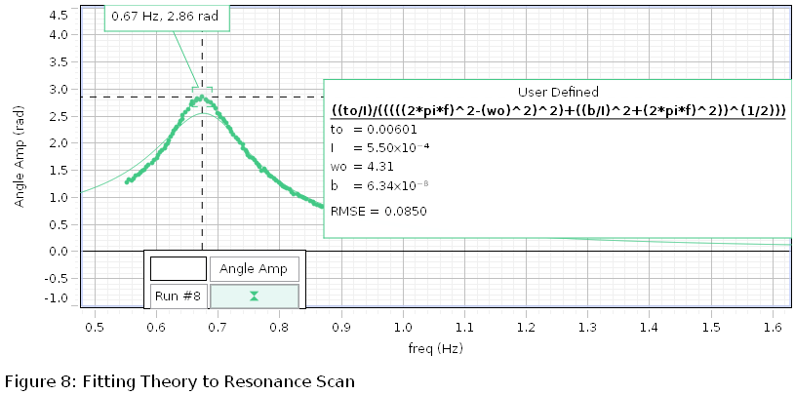

*Figure9. Fitting Theory to Resonance Scan*

As shown in Figure 9, damping coefficient , resonant frequency

* 1. **Phase Analysis**

According to Equation 11, we have a function:

Also, we have Figure 10, plotting three phases difference

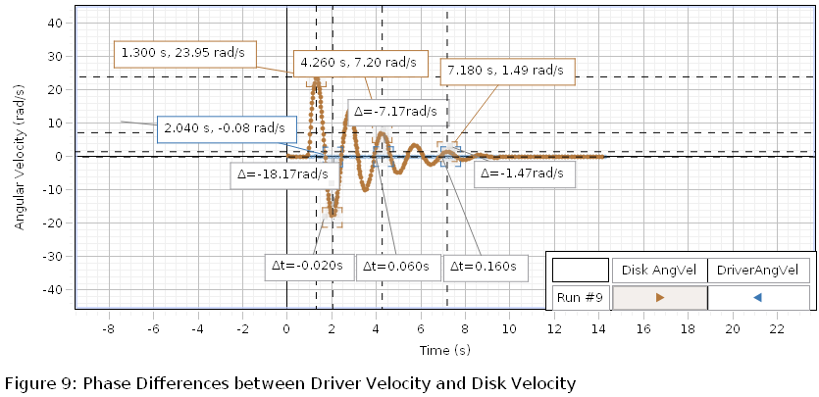

*Figure10. Phase Difference*

*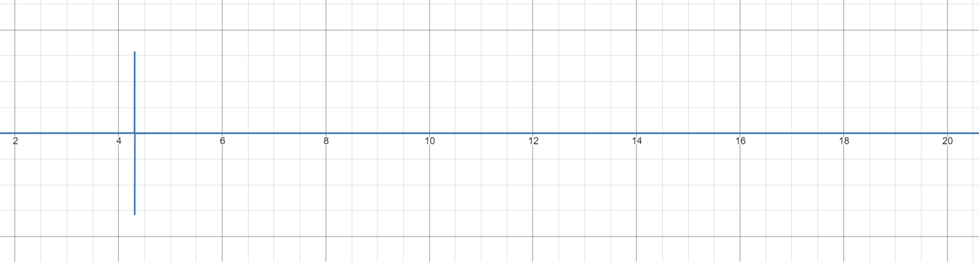Figure11. Graph of Equation 14*

If we observe these two figures, we have to consider the Equation 11 makes no sense. However, due to the low accuracy for driver angel measurement, it is not surprising.

1. **Conclusion:**

In Driven Damped Oscillations, the magnitude of friction does not affect the frequency of the maximum angle amplitude but the magnitude of maximum amplitude. Also, it does not change the distribution of angle amplitude. Furthermore, the distribution is not symmetric due to the restriction of the domain. However, due to the condition of experiment utilities and time limit, it is still abstract about the relation between frequency and phase difference. We still need continuous work to figure it out.